# **Installing Vivado and Digilent Board Files**

This guide will show the process of installing and configuring the Vivado development environment, used for developing projects to run on Digilent FPGAs. In addition to the installation, Vivado will be pointed at Digilent's board support files, which are used to make the process of creating a new project significantly faster. In addition, the board files make it significantly easier to add a variety of peripherals (such as DDR memory) to a project.

**Guide**

## Installing Cable Drivers on Linux

Windows users may skip this section and continue on to [Step 2](https://reference.digilentinc.com/vivado/installing-vivado/start#installing_digilent_board_files).

### Install driver

The Vivado installer does not install the USB drivers required to recognize an FPGA on a Linux system, regardless of whether the option was checked or not. In order to install these drivers, navigate to the *“<Vivado Install>/data/xicom/cable_drivers/lin64/install_script/install_drivers/”* directory in a console window. The *“<Vivado Install>”* directory is typically the *“/opt/Xilinx/Vivado/*/”* directory - the “*” representing the Vivado version number (2018.2). From within this directory, run the **“./install_drivers”** command as a super-user. Once this command completes successfully, the required drivers will be installed.

**NOTE**: Some older versions of Vivado may require that the install_drivers command be extracted from a TAR file before use.

[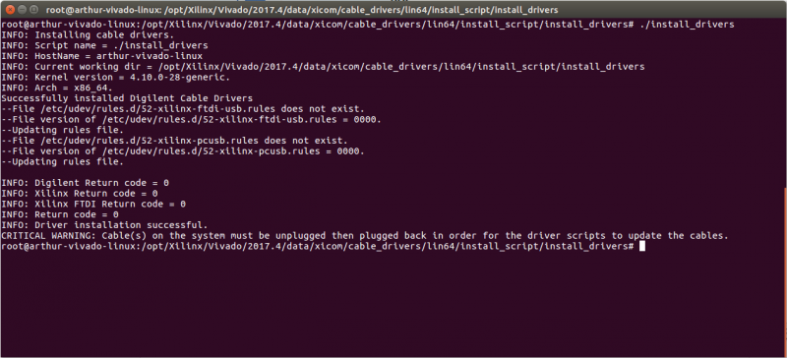](https://reference.digilentinc.com/_detail/vivado/installing-vivado/linux-drivers.png?id=vivado%3Ainstalling-vivado%3Astart)

### Enable port use

In order to use the USB drivers with a serial terminal, each user that will be using serial terminals must be added to the dialout group. Serial terminals can be very useful for debugging FPGA designs that implement a USB-UART controller. A user can be added to the dialout group with the **“sudo adduser $USER dialout”** command. Note that this only adds the user that is currently active. In order to add a non-super-user while authenticated as root, use the command **“adduser <username> dialout”** instead, with “<username>” replaced with the name of the user to be added.

[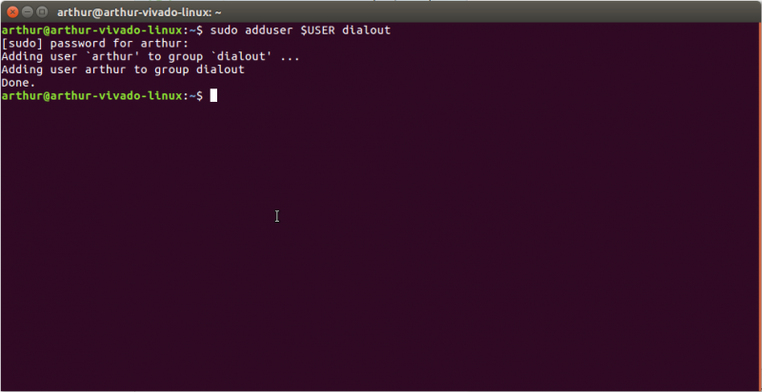](https://reference.digilentinc.com/_detail/vivado/installing-vivado/linux-dialout.png?id=vivado%3Ainstalling-vivado%3Astart)

## Installing Digilent Board Files

### Get board files

Download the [archive](https://github.com/Digilent/vivado-boards/archive/master.zip) of the vivado-boards Github repository and extract it wherever desired.

### Edit tcl script

Open the file “Vivado_init.tcl” in the “utility” subdirectory of the vivado-boards repo. This file is a script that will be run whenever Vivado is launched. It will load Digilent's board files for use in Vivado from the directory they were extracted into. Change the text *“<extracted path>”* in the script to the extracted location of vivado-boards. **Save** and **close** the file.

**NOTE:** The file init.tcl should be used instead of Vivado_init.tcl when installing Vivado versions 2016.4 and older.

[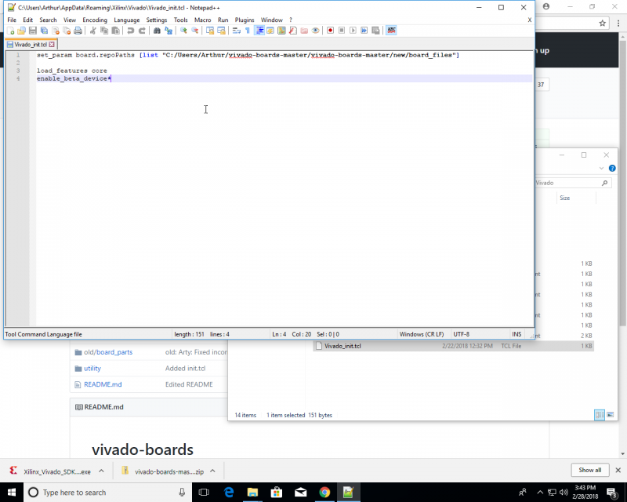](https://reference.digilentinc.com/_detail/vivado/installing-vivado/edit-init-tcl.png?id=vivado%3Ainstalling-vivado%3Astart)

### Move the tcl script

Copy Vivado_init.tcl and paste it into the *“%APPDATA%/Xilinx/Vivado/”* directory for Windows or *“$HOME/.Xilinx/Vivado/”* (after authenticating as superuser) in Linux.

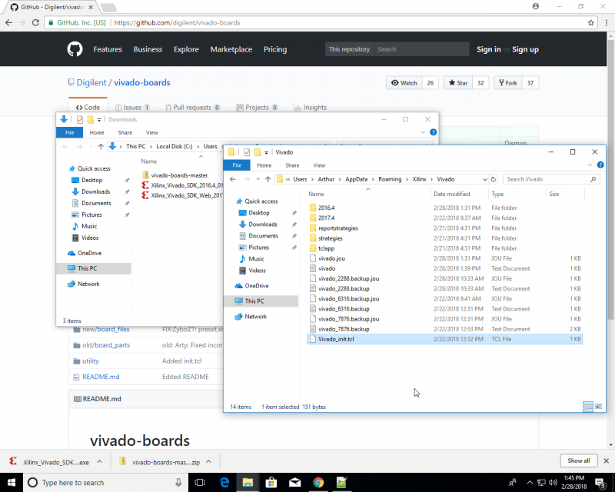

## Conclusion

Vivado has now been installed and it has access to Digilent's board files! To begin using Vivado to develop a project, check out one of the tutorials below:

* [Getting Started with Vivado](https://reference.digilentinc.com/vivado/getting_started/start)
* [Getting Started With Vivado IP Integrator](https://reference.digilentinc.com/vivado/getting-started-with-ipi/start)